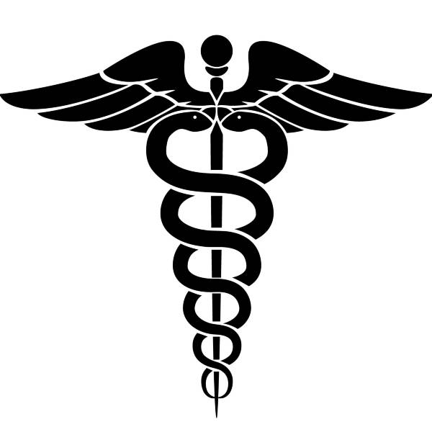

Principles of Health Science
If you are interested in a career in the Health Field, this is the class for you!
You will learn Anatomy, Physiology, Medical Terminology, CPR certification and will receive one elective credit. You must have taken Biology previous to this class.
This class is a prerequisite for the Health Science Internship Class. To get into the Internship class, you will need a recommendation from all of your teachers. You will be selected for the Internship by your recommendations as well as your GPA , attendance, attitude, discipline, as well as your work ethics.

Health Science
If selected for this Internship class, you will be privileged to go to Memorial Hermann/ Memorial City Hospital three days a week. You will be allowed to observe in the majority of the clinical units in the hospital. This includes the Operating Room, Emergency Room and other clinical settings in the hospital plus outside areas, a Veterinary Clinic and Sports Medicine clinic. You will shadow a professional from the area you are assigned and will have the chance to ask questions of the professional.
During this class, you will be given the opportunity to teach elementary students and help during the school Blood Drives. You will tour the Greater Houston Blood Bank as well as Herman Hospital and the Life Flight.
During this course you will learn Leadership Skills.
You will receive 2 Elective credits

